Mullion Cricket Club
Junior Cricket Coaching

Mullion Cricket Club would like to invite current and new members to join their junior coaching sessions which take place at Mullion School (in the gym) on a Monday evening from 15th January 2018. Sessions will continue outside at the cricket club from Easter.

The session times are as follows :
- U9’s 5.30-6.30pm
- U11’s 6.30pm-7.30pm
- U13’s 7.30pm-8.30pm
- U15’s from Easter

For more information please contact Junior Cricket Secretary
Kim Turner on 01326 241344 or email kimmturner@btinternet.com
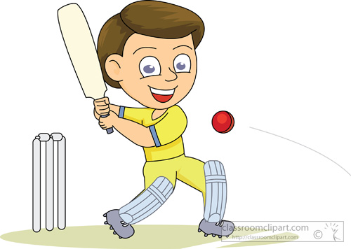

All of the coaches at Mullion Cricket Club hold the relevant coaching qualifications and safeguarding certificates for working with young children.

