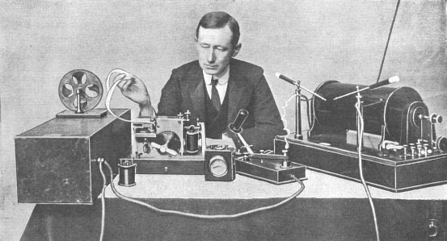
Choughs Class
TOPIC TITLE
Spring 2019
Our Topic is
Communication

Learning across the curriculum |  | Subject Key Skills
English  Writing, Imagining and Presenting  - Writing poetry.  - Writing instructions for games.  - Writing stories linked to famous people.  - Information texts – researching Florence Nightingale and other inventors and scientists.  Mathematics  - Multiplication & Division  - Statistics  - Geometry – properties of shape  - Fractions  - Addition and Subtraction word problems | Religious Education  Looking at Christianity, the Bible and the features of a church. Focus on Jesus as a historical figure and how he communicated his teachings on love and forgiveness. The importance of Easter.  Looking at Judaism and the Torah. The Ten Commandments and stories such as The Creation.  PSHE  What is communication?  How do we show that we care about each other and the people in our community? | Geography  Where in the world did famous scientists and inventors come from?  History  How has information technology changed over time?  Look at Marconi.  Visit the Telegraph Museum, Porthcurno & the Marconi Centre, Mullion.  Art & Design  How do artists communicate their feelings through different media.  PE  Multi-skills.  Communication through dance. | Science  Scientists and their discoveries. The children will look at the discoveries of Louis Pasteur,  Elizabeth Garrett Anderson,  Jane Colden and Guglielmo Marconi.  DT  Design and make greenhouses.  Music  Using African drums to explore communication through sound and rhythm.  Computing  Following the internet safety programme – “Think you Know”.

