Prospectus

Little Lizards Children’s Centre
Landewednack CP School
Beacon Terrace
The Lizard
Cornwall
TR12 7PB

Tel: 01326 290066
e-mail address: littlelizards@landewednack.cornwall.sch.uk

Contents

Introduction 3
Message from the Board of Governors 4
Our Aims 4
To Provide 4
Our Values 4
Our Day 5
School Meals 5
Key Worker System 6
Learning Journals 7
Two Year Old Progress Check 7
Early Years Foundation Stage 8
Personal, Social and Emotional Development 8
Communication and Language 9
Physical Development 9
Literacy 10
Numeracy 10
Expressive Arts and Design 11
Knowledge and Understanding of the World 11
Parent and Toddlers Group 11
Insurance 11
Complaints Procedure 12
Calendar of Events 12
OutdoorVisits & Journeys 12
Governors with Responsibility 12
Staff 12
Our Rules 12
Pastoral Care 13
Charges & Remissions 13
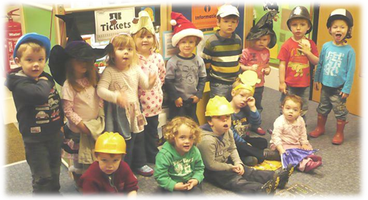
Raising Money for Children in Need

Introduction

Little Lizards is a registered centre where children are well cared for by qualified and experienced staff. Our centre’s main education ethos is learning through play.

At Little Lizards we believe that the key to young children’s learning is well-planned play, which covers all the seven key areas of a child’s learning and development:

The three prime areas:
- Communication and language.
- Personal, social and emotional development
- Physical development

And four specific areas:
- Literacy.
- Maths.
- Understanding the world.
- Expressive art and design.

Our aim is to ensure all children are well cared for in a safe and stimulating environment. We are an equal opportunities setting which provides opportunities for all children to succeed and feel valued.

Play underpins the development and learning for all our children. The staff provide well-planned experiences based on spontaneous play both indoors and outdoors, allowing children to learn with enjoyment and challenge.

Little Lizards Children’s Centre is set in a self-contained building within Landewednack school grounds. It has a large main playroom as well as a purposely designed quieter area. Outside play is catered for in a secure fenced off area, with use of the school field and the sports hall when necessary.

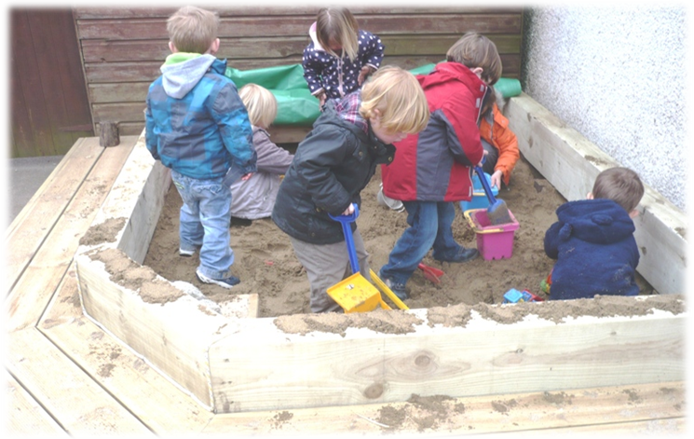

Message from the Board of Governors
Our Sandpit

Little Lizards Children’s Centre plays a major part in the extended school’s delivery. It provides day care for two to five year-olds all the year round, a breakfast club, an after-school club and a holiday club for 2—11 year old children.

The facilities, which are managed by the school, have their own team of qualified staff and bring a whole range of extra assets to the local community and provide a safe school environment for children from the age of two.

The centre has a well-equipped main room and a quiet room that can be used for visiting professionals like nurses and includes many innovative energy-saving features. Our outdoor play area provides opportunities for children to take part in physical, imaginative and co-operative play.

Our Aims

To Provide

☑ High quality care and learning for all children in our setting.
☑ An environment that is safe and secure as well as stimulating, friendly and welcoming to all children, parents and staff.
☑ A place to take learning forward and to provide opportunities for children to succeed in an atmosphere of care and feeling valued.
☑ Well planned play, both indoors and outdoors which is a key way for children to learn with enjoyment and challenge through all areas of personal, social and educational development, taking into account the areas of learning suitable to age and ability.
☑ Activities which are inspired by the interests of our children.

Our Values

☑ Regarding children as individuals
☑ A partnership with parents/carers/school, outside agencies and the community.
☑ Promoting Equal Opportunities for children and staff.
☑ Providing opportunities for further training and development for staff
☑ Ensuring a good relationship between all the people who use the setting
☑ Learning through ongoing stimulating and structured play with a challenge
☑ Providing opportunities for children to develop confidence and self esteem
☑ Ensuring children and staff are praised
☑ Providing high quality staff
☑ Providing high quality care

Our Day

Our day starts at 8.00am for breakfast club; children will not be admitted before this time. During this time children aged 2 to 11 may attend. School aged children will be allowed into school at 8.50am.

Our morning nursery session starts at 9.00am. Tuck time is at 10.15am when a healthy snack will be provided. At 12 noon children have a choice of a cooked meal provided by the school for an additional charge of £2.20, or a packed lunch brought from home. Daycare ends at 3.00pm. Parents/careers are asked to wait outside main door of Little Lizards; a member of staff will bring your child out to you. If you need to pick up early please let a member of staff know when you drop off. During the afternoon a small snack is provided for the children.

After school club commences at 3.00pm for Daycare children and 3:15 for the school children. A member of staff from school will bring the children into Little Lizards for the start of after school club. During after school club a variety of activities will be on offer as will a quiet area should any children wish to do homework. A snack will be provided during this time. Our day ends at 6pm.

During the school holidays Little Lizards offers a Holiday Club for 2-11 year olds that runs from 8am – 6pm. A Letter will be sent out to book your child in for holiday club (Your child will require a packed lunch as the school kitchen is closed during the holidays). Little Lizards closes on School inset days for training.
Please Note: If you are late picking up, relevant charges will apply.

School Meals

A lunchtime meal is cooked on the premises and costs £2.20 at present. Children may bring a packed lunch or go home if you prefer. A menu is displayed on the notice board and on the school website. Dinner money should be paid at the beginning of the week or the morning of the day the meal is taken. Please put the correct money in a sealed envelope, marked with your child’s name, the amount enclosed and the dates the meals are to be taken, and put it in the letter box by the office door. Cheques for the whole week or a longer period should be made to ‘Landewednack CP School’.
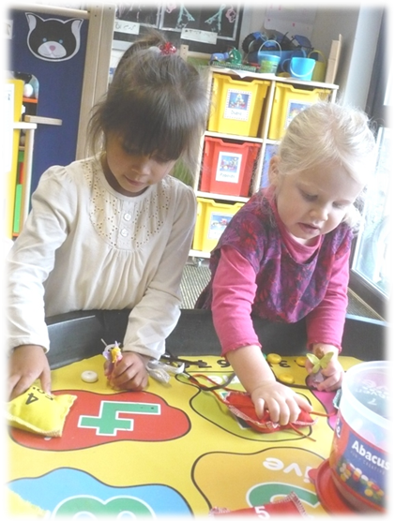
`
Key Worker System
Number Counting with Beads
“Working together makes a job twice as much fun”

A key worker has special responsibility for a group of children. Parents and children know the name of their key worker from the beginning of their involvement with the setting. A key worker will ensure that the needs of each child are recognised within the setting, so that the overall planning is devised to meet these needs. You can see who your child’s key worker is on the parent’s board above the pegs or ask a member of staff.

The main duties of a key worker are:
- To assist the child to settle into the setting
- To provide for the emotional needs of the child, e.g. to comfort and reassure the child at any time
- To care for the child, e.g. to assist with toileting as necessary
- To plan for that child ensuring that the child’s race, culture, religion and language are taken into account
- Observing, keeping records and monitoring the child’s progress
- Liaising with parents/carers
- To develop a good rapport with parents/carers, informing them of their child’s activities
- To contribute information about individual children’s needs, whilst respecting confidentiality as necessary.

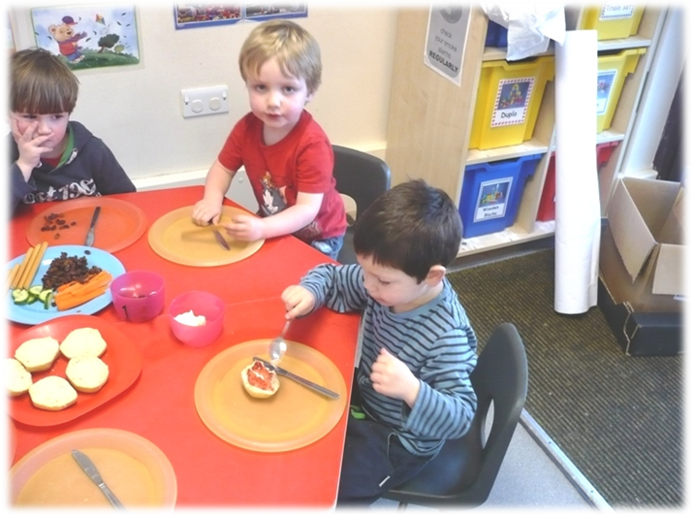
Making our own Snack on St Piran’s Day
Scone, Jam and Clotted Cream - Yum

Learning Journeys

Each child attending Little Lizards will have their own learning journey in line with the Early Years Foundation Stage, this is a record of their learning and achievements during their time with us. It will be full of photographs, the child’s work and observations and comments made by the staff and input from parents. This will be yours to keep when your child begins full time school.

Two Year Old Progress Check
In 2012 the government introduced a Two Year Check within all child care settings, which will link into the Two Year Old Health Review, which is completed by a member of the Health Visitors team. This will provide information to go into your child’s “Red Book” (Personal Child Health Record) and will act as a link between health and education settings. Your child’s Key Worker will complete the progress check and you will be invited to meet up with them in order to discuss and add your views to the assessment.

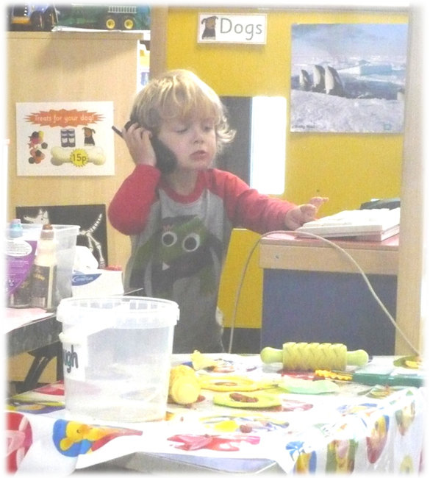
“Hello, this is Little Lizards Café, I’d like to order some pasties please”

Early Years Foundation Stage

At Little Lizards we use the following outlines for early learning, based on the revised Early Years Foundation Stage document. There are seven areas of learning and development, which are all important and inter-connected. Three areas are particularly crucial in building the children’s capacity to learn, form relationships and thrive. These are called the prime areas and include communication and language, physical development and personal, social and emotional development. In addition to these are the four specific areas, which include, literacy, maths, understanding the world and expressive arts and design.

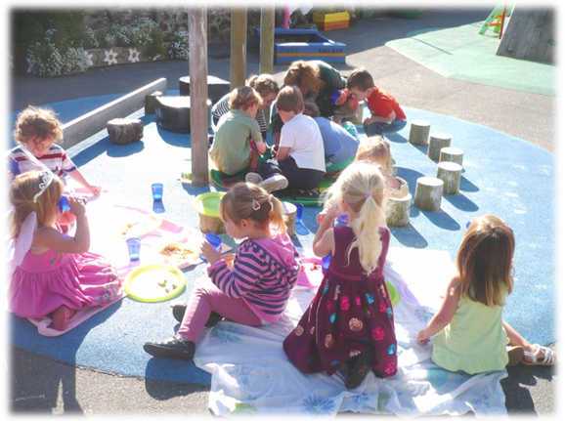
Summer Picnic

Personal, Social and Emotional Development

Successful personal, social and emotional development is critical for young children in all aspects of their lives. It is also a pre-requisite for their successes in all other areas of learning. Little Lizards provide the experiences and support, which will enable the children to develop a positive sense of themselves and others.

We give particular attention to:

- Establishing constructive relationships with children, other practitioners, children and practitioners together, parents and other agencies.
- Finding every opportunity to give positive encouragement to children, with staff providing a positive role model, to enable them to have confidence in their own abilities.
- Ensuring there is adequate time and space for children to be able to develop their own interests.
- Providing opportunities for play and learning that acknowledge children’s particular beliefs and backgrounds.
- Provide support and a structured approach to achieve successful social and emotional development of all children and especially those with particular behavioural or communication difficulties.
- Develop social skills and learn how to manage their own feelings.
- Understanding appropriate behaviour in groups and in different situations.

Communication and Language

The development of Communication and Language depends on children having the confidence, opportunity, encouragement, support and disposition to use them. This area of learning includes speaking and listening in different situations and for different purposes, reading a range of simple texts and writing for a variety of purposes.

In order to give all children the best opportunities for effective development and learning in this area we pay particular attention to:
- Providing opportunities for children to communicate thoughts, ideas and feelings and to build up relationships with adults and each other.
- Enabling the children to experience a rich language environment.
- Planning an environment that reflects the importance of language through signs, notices and books.
- Developing their confidence and skills in expressing themselves.
- Early identification of and response to any particular difficulties in children’s language and development.
At first all learning arises from physical action and the gathering of experiences through the senses. This means children learn best when the activity engages many senses. Initially a child’s attempts to communicate will be non verbal as language skills develop thought becomes less dependent on action. Non verbal messages remain an important form of communication throughout life.

Physical Development

Young children grow rapidly at this stage in their lives. They develop confidence and control in the way they move and the way in which they handle tools and equipment. At Little Lizards we will provide opportunity for children to be active and move about in a variety of different ways in order to develop many of these fundamental skills.

We will provide opportunities to:

- Develop co-ordination, control and movement through a range of gross and fine motor activities.
- Tackle appropriate physical challenges through effective planning.
- Understand the importance of physical activity and how to make healthy food choices.
- Introduce the language of movement to children alongside their actions.
- Ensure that there is sufficient opportunity and time for children with physical disabilities or motor impairments to develop their physical skills. This will be achieved by working as necessary with physiotherapists and occupational therapists.

Literacy

The development of literacy skills involves:
- The development of good speaking and listening skills.
- The provision of an environment that reflects the importance of language through signs, notices and books.
- Developing the children’s enjoyment and enthusiasm for stories and poems.
- Providing opportunities for mark making in a range of different contexts.
- Encouraging children to listen to and recognise different sounds.

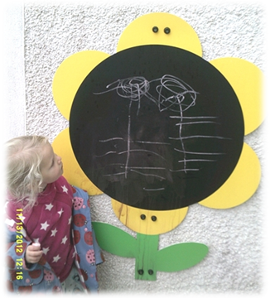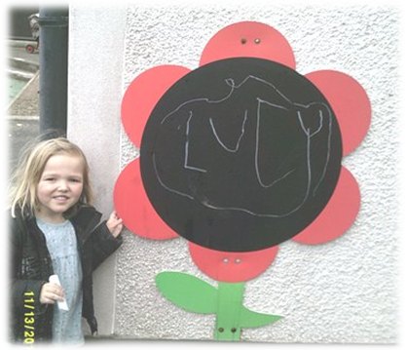
Mark Making with Different Media

Numeracy

Mathematical development, including later numeracy, depends on becoming confident and competent in learning and using key skills. This area of learning includes counting, sorting, matching, patterns and working with numbers, shapes, spaces, and measures.
Mathematical understanding will be developed through stories, songs, games, practical activities and imaginative play, so that children enjoy using and experimenting with numbers, including numbers bigger than ten.

At Little Lizards mathematical development will take place in many forms, these include:
- Observing numbers and patterns in the environment and daily routines.
- Planned activities that are imaginative and enjoyable.
- Practical activities which are underpinned by children’s developing communication skills.

Expressive Arts and Design

Creativity is fundamental to successful learning. The aspects covered in this area include art, music, dance, role-play and imaginative play. Being creative enables children to make connections between one area of learning and another and so extend their understanding.

At Little Lizards we wish to give all children the best opportunity possible for effective creative development, this will be achieved by providing:

- Activities using music, movement, dance and role play.
- Resources that reflect a variety of different cultures to stimulate different ways of thinking.
- Opportunities to work alongside artists and other creative adults, using a wide range of media and materials.
- A wide range of activities will be available which children can respond to using many senses.

Understanding the World

In this area of learning, children are developing the skills, knowledge and understanding that help them make sense of the world. This forms the foundations for later work in Science, History, Geography, and Information Communication Technology (ICT).

We aim to pay particular attention to:

- Activities based on first hand experiences which encourage exploration, problem solving, decision making and discussion.
- Providing a wide range of activities both indoors and outside that stimulate children’s interest and encourage curiosity.
- Supplementary experience and information for children with sensory impairment.
- Opportunities to help children become aware of explore and question differences in people and the world around them.

Parent and Toddlers Group

A Parent and Toddlers Group welcomes children from birth to 5 and runs from 9.30 to 11.30 on a Friday morning, in the Community Hall, in the school.

Insurance

Little Lizards has a comprehensive insurance policy in place. We are insured to deliver child care between the times of 8am and 6pm.

Complaints Procedure

Please refer to the Complaints Policy which, along with other documents, policies and information is available on request. Please speak to a member of staff.

Calendar of Events

During the year we have many activities taking place, and these include both setting and village events. Dates for each of these events will be published and detailed information will be sent at an appropriate time beforehand, in the weekly newsletter. Information can also be found on the school website at www.landewednack.cornwall.sch.uk

OutdoorVisits & Journeys

Little Lizards has a policy for Outdoor Education activities. Under the terms of this policy parents will be asked to complete a consent form with regard to outdoor visits.

Governors with Responsibility

Mrs Louise Jones Head Teacher/Setting manager
Mrs Elaine Broscomb Premises Governor
Mrs Alix Lord Early Years’ Governor/Chair of Governors

The Governors with responsibility for Little Lizards report back to the school’s Board of Governors when they meet each half term.

Staff

Suzanne Ely Senior Nursery Nurse
June Evans Senior Nursery Nurse
Angela Haskell Nursery Nurse
Millie Lake Nursery Nurse

Our Rules

Do as you are asked
Listen carefully
Only run outside
Keep hands and feet to yourselves
Be polite to everyone

Pastoral Care

While they are at Little Lizards, the staff are in ‘loco-parentis’ with regard to the children in their care. In the event of an accident of a serious nature, every effort will be made to contact the child’s parents as soon as possible. If a child is taken ill and it is considered wise to send the child home, the parents will be contacted. Please ensure we have a telephone number to contact you during the day.

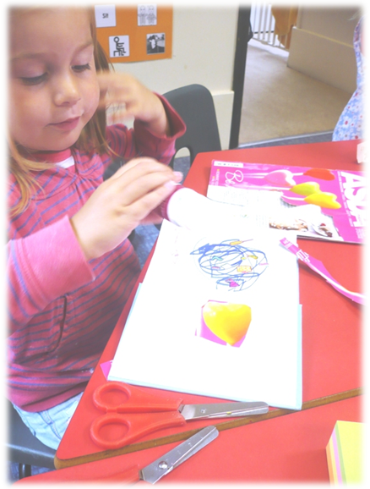
If your child is asthmatic and needs an inhaler to be available at Little Lizards, please ensure it is clearly named. Currently these are kept in the office. The school and Little Lizards have an emergency asthma kit available. If your child has been prescribed medicine to be taken in the course of the day, such as an antibiotic and it needs to be administered by a member of staff, please see a member of staff to sign the permissions book.

If your child is not yet dry, we are happy to either change nappies, or, once you have begun to toilet train them, we are happy for them to come in pants and deal with any ‘accidents’. We ask parents to send in a bag with a change of clothes, nappies and cream in.

Please make sure there is a named change of clothes left in the centre for your child in case of accidents with water play.
Craft using a range of media

Please inform us of any home circumstances which may be having an adverse effect on your child.

Term Dates - Year 2016/2017
The In-service training days for 2016/2017 are 5th September, 6th September,
20th & 21st October 2016 and 26th May 2017

Autumn Term 2016
Monday 7th September – Friday 18th December
(Half term—Monday 24th October – 28th October 2016 Inc.)

Spring Term 2017
Tuesday3rd January – Friday 31st March
(Half Term - Monday 13th February - Friday 17th February Inc.)
(Easter – 3rd April – 18th April Inc)

Summer Term 2017
Tuesday 18th April – Friday 26th July
(Half Term - Monday 29th May - Friday 2nd June Inc.)
May Day bank holiday Monday 1st May 2017

Charges & Remissions
With effect from September 2015 charges for childcare will be:

Breakfast Club £3.75 | Afterschool Club
 | 3.15-4pm £2.00
Daycare (open 38 weeks per year) | 4-4.30pm £1.50
Morning session -9am–12noon £11.25 | 4.30-5pm £1.50
Lunchtime session – 12noon-1pm £3.75 | 5-5.30pm £1.50
Afternoon Session – 1-3pm £7.50 | 5.30-6pm £1.50
Hourly rate (2/3 yrs). £4.00
(3/4 yrs) £4.00
Holiday club
Morning session - 8-1pm £11.00 | Whole day £22.00
Afternoon Session - 1–6pm £11.00 | Hourly £2.50 p/h

Please note that no school meals will be provided during the holidays and parents will have to supply a packed lunch.

While we appreciate that most parents pay their invoices on time, unfortunately, due to the amount of time and money we are spending chasing late payments, from September 2015 we will be invoicing in advance for all daycare and holiday club booked for the following month. This brings us in line with other day-care providers.

Additional hours, including breakfast club and afterschool club will be invoiced in arrears at the beginning of the next month along with the daycare for the following month. This invoice will need to be paid by the end of that month to enable children to attend Little Lizards. Payment can be made by cash, or a cheque made payable to ‘Landewednack CP School’ in a sealed envelope marked with your child’s name, the amount enclosed and what it is for and put in the letter box by the office.

Dinner money is payable separately, in advance.

Please see our Attendance and Payment policy at www.landewednack.cornwall.sch.uk—follow the Little Lizards Children’s Centre link and then ‘policies’

For any further information please contact us on 01326 290066.

