ATTAINMENT DATA JUNE 2024

EYFS Profile

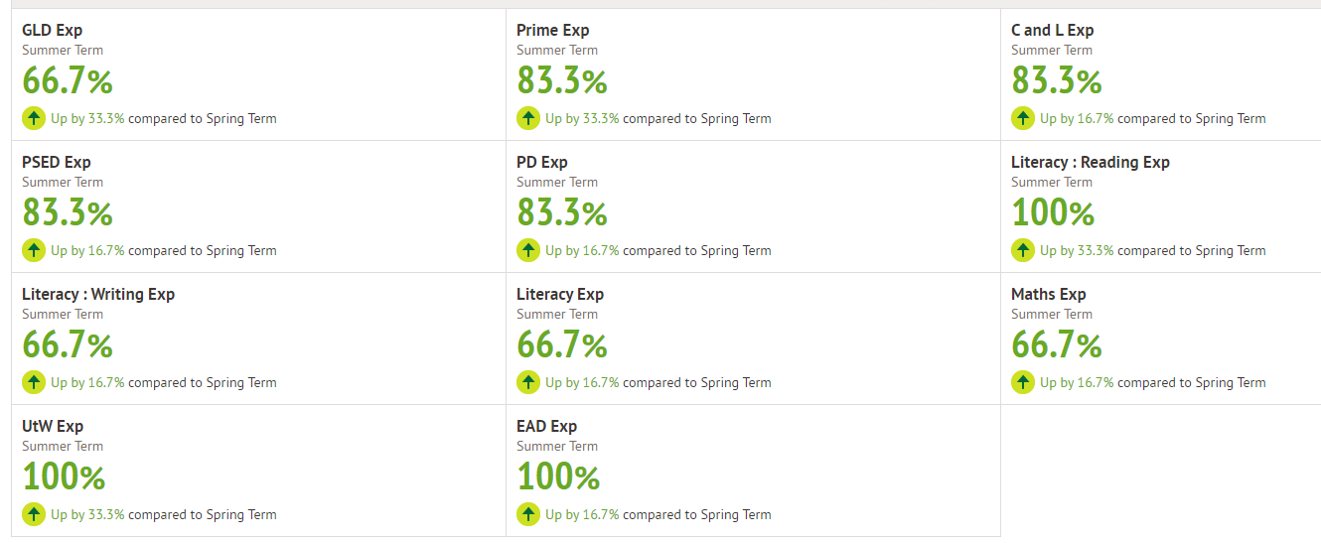

|  |  |
| --- | --- |
| Year One | National Expected |
| Phonics Screening Check | 100% |
| Phonics Screening Check retakes | N/A as 100% passed last year when in Y1 |

.

**End of KS2 SATs and Teacher Assessment for Writing**

|  |  |  |
| --- | --- | --- |
|  | National Expected+ | Greater Depth |
| GPS | 100% | 36% |
| Reading | 100% | 36% |
| Writing | 91% |  |
| Maths | 91% | 36% |